|  |
| --- |
| ID: 2024458 |
| Class: CSCI 2125-001 |
| Due: 12/2/2011 |
| Assignment: Homework 5 |

ID: 2024458

Class: CSCI 2125-001

Date: 12/2/2011

Assignment: Homework 5

**Testing Output Screenshot**

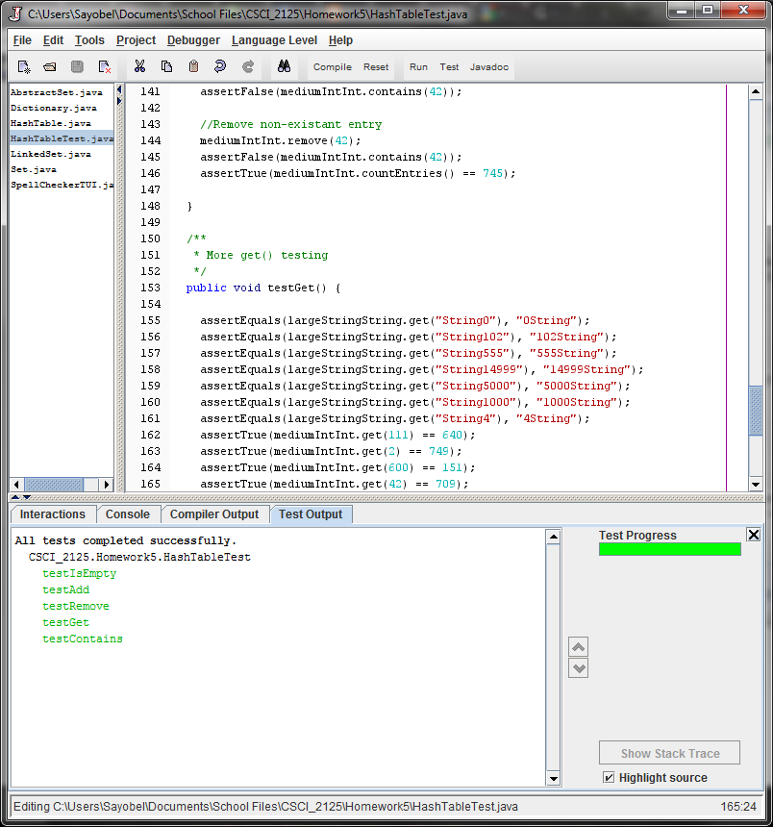

ID: 2024458

Class: CSCI 2125-001

Date: 12/2/2011

Assignment: Homework 5

**Program Output Screenshot**

